BI Technical Solution Documentation

**Prepared for The Dow Chemical Company**

September 15, 2025

**CLIENT LOGO**

**Proprietary Notice & Confidentiality:**

The information contained in this document is proprietary to The Dow Chemical Company. The methodology used to prepare this document is proprietary to The Dow Chemical Company and 3Cloud Solutions Inc. Neither may be used, reproduced, or disclosed to others except employees of the recipient of this document who have need to know of the purposes of this assignment.  
  
This document will serve as a collaboration framework for 3Cloud and The Dow Chemical Company defining the agreed technologies, frameworks, and designs to be implemented.

**Purpose:**

This Technical Solution Documentation is aimed at communicating the technical details of the work that has been done with the WAV Reports for The Dow Chemical Company. It will serve as the blueprint that developers and administrators will refer to.  
  
This document will serve as a collaboration framework for 3Cloud and The Dow Chemical Company defining the agreed technologies, frameworks, and designs to be implemented.

Table of Contents

Power BI: 5

Solution Overview: 5

Product Deployment 5

WAV Report Model Diagram: 5

WAV Microzone Report Model Diagram: 6

WAV System Health Report Model Diagram: 6

Dashboard Access: 6

Report/Dashboard Components: 6

Metrics/KPIs/Key Figure Definitions: 13

Refresh Schedule: 13

Document Control 14

Glossary 15

# Power BI:

Power BI is a collection of software services, apps, and connectors that work together to turn your sources of data into coherent, visually immersive, and interactive insights. Your data might be an Excel spreadsheet, or a collection of cloud-based and on-premises hybrid data warehouses.   
(reference: <https://learn.microsoft.com/en-us/power-bi/fundamentals/power-bi-overview)>

# Solution Overview:

This project used Power BI semantic model as a consumption layer of the Reports. Power BI desktop was used for the development of the report and Power BI service with a premium capacity license to host the reports and/or dashboards.

|  |  |  |
| --- | --- | --- |
| **Semantic Model** | **Environment** | **Workspace** |
| **DEV_WAV Model 2691 BETA TEST_WAV Model 2691** | Development and Test | Test – Worker & Asset Visibility |
| **WAV Model 2702** | Production | Worker Visibility |

# Product Deployment

This project used Sharepoint site as a Software Development Cycle (SDLC) for Power BI reports.

# Dashboard Access:

# Report/Dashboard Components:

## WAV Report: This is the default view of the WAV Report. In this page, highlighted in red box, we can use these buttons to also navigate to either WAV System Health Report or WAV Microzone Report.

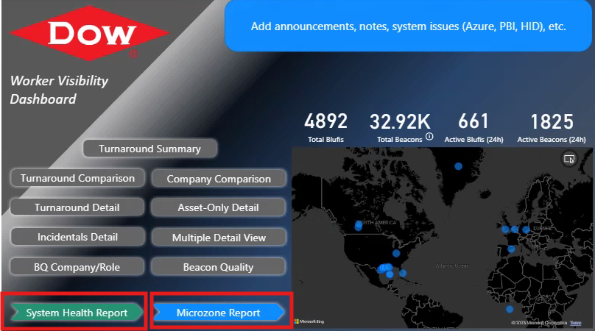

## 

## This is the Turnaround Summary page of the WAV Report. Highlighted in red box are the notable navigation button and filtering capability inside this page.

## This is the WA Hours Company/Role page, you can get here from the Turnaround Summary page. Highlighted in red box are the notable navigation button and filtering capability inside this page.

This is the Turnaround Comparison page of the WAV Report. Highlighted in red box are the notable navigation button and filtering capability inside this page. It has matrix visual that can be expanded or collapse with that “+” button for more information.  
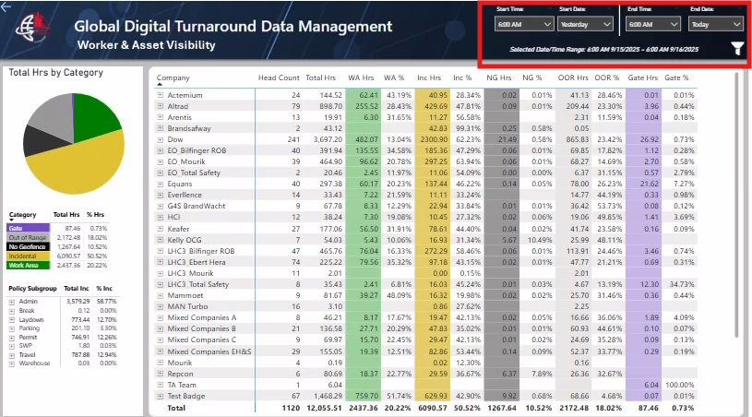

This is the Company Comparison page of the WAV Report. Highlighted in red box are the notable navigation button and filtering capability inside this page. In each visual, there’s also slicer to use for filtering purposes.

This is the Turnaround detail page of the WAV Report. Highlighted in red box are the notable navigation button and filtering capability inside this page.  
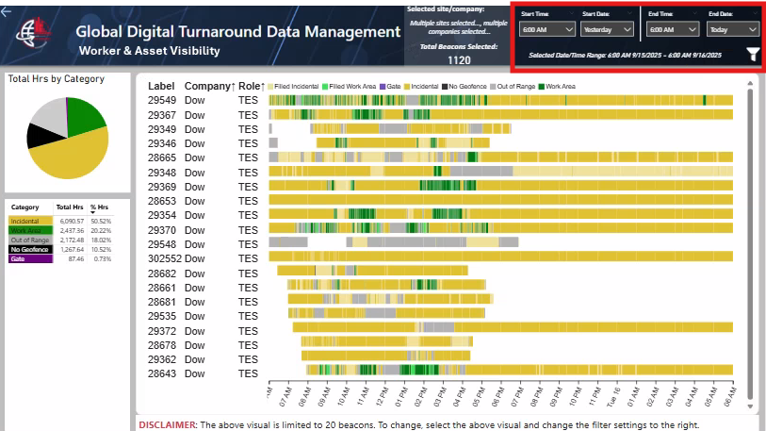

This is the Incidentals detail page of the WAV Report. Highlighted in red box are the notable navigation button and filtering capability inside this page.

This is the Asset-only detail page of the WAV Report. Highlighted in red box are the notable navigation button and filtering capability inside this page.

This is the Multiple detail view page of the WAV Report. Highlighted in red box are the notable navigation button and filtering capability inside this page. In this page, can also filter by Company, by Role, by Company and Role.  
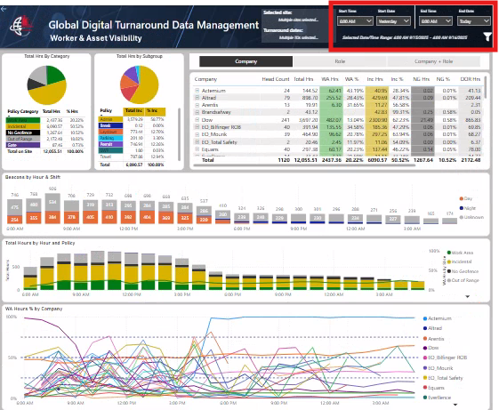

This is the Beacon Quality page of the WAV Report. Highlighted in red box are the notable navigation button and filtering capability inside this page. It has matrix visual that can be expanded or collapse with that “+” button for more information.  
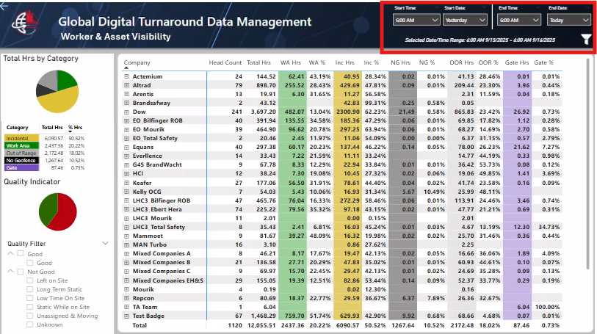

This is the BQ Company/Role page of the WAV Report. Highlighted in red box are the notable navigation button and filtering capability inside this page.  
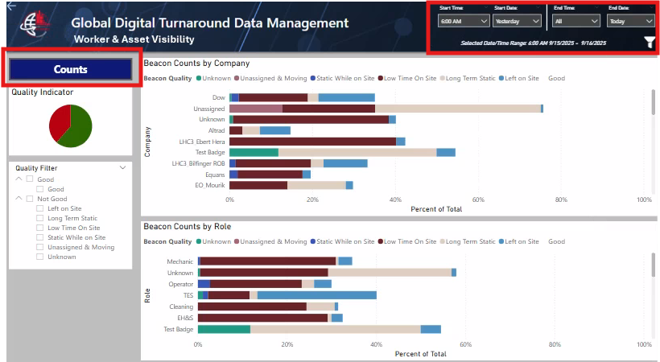

This is the Counts BQ Company/Role page, you can get here from the BQ Company/Role page. Highlighted in red box are the notable navigation button and filtering capability inside this page.

# 

# Metrics/KPIs/Key Figure Definitions:

|  |  |  |
| --- | --- | --- |
| **Metric** | **Formula** | **Description** |
|  |  |  |
|  |  |  |

# Refresh Schedule:

|  |  |  |
| --- | --- | --- |
| **Report Name** | **Workspace Name** | **Refresh Frequency/Schedule** |
|  |  |  |
|  |  |  |
|  |  |  |
|  |  |  |
|  |  |  |
|  |  |  |

# Document Control

|  |  |  |  |
| --- | --- | --- | --- |
| **Date** | **Authors** | **Version** | **Change Description** |
| 09/15/2025 |  | 1.0 | Initial release |